UL Report Notes

Here are very simple one-line explanations for each algorithm:
K-Means Clustering: Groups data into K clusters by assigning each point to the nearest cluster center.
Expectation Maximization (EM): A probabilistic clustering method that estimates the probability that each point belongs to each cluster.
Random Projection: Reduces dimensionality by projecting data into a lower-dimensional space using a random matrix while approximately preserving distances.
Principal Component Analysis (PCA): Reduces dimensions by finding new axes that capture the maximum variance in the data.
Independent Component Analysis (ICA): Transforms data into components that are statistically independent from each other.
t-SNE (Nonlinear Manifold Learning): Projects high-dimensional data into 2D or 3D while preserving local neighbor relationships for visualization.

Your assignment has 5 main algorithms in two categories:
- Clustering (unsupervised learning)
- Dimensionality Reduction (feature transformation)
I’ll explain each at a high level, focusing on what the algorithm is trying to do and how it works conceptually.

1. K-Means Clustering
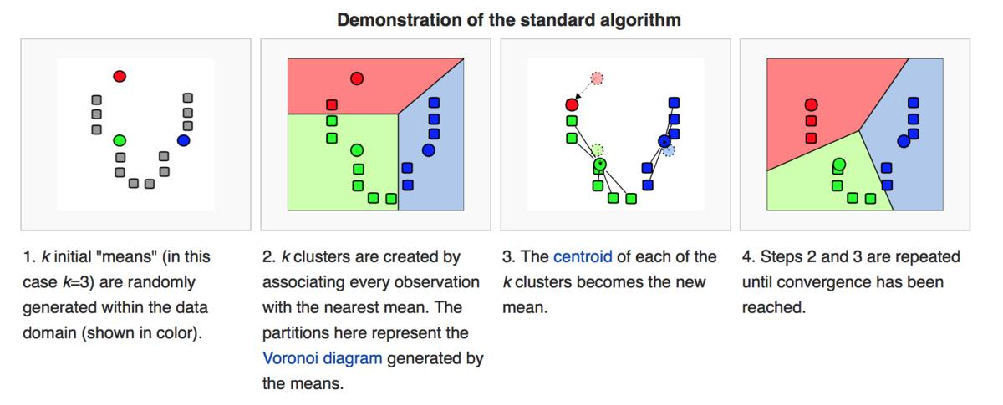
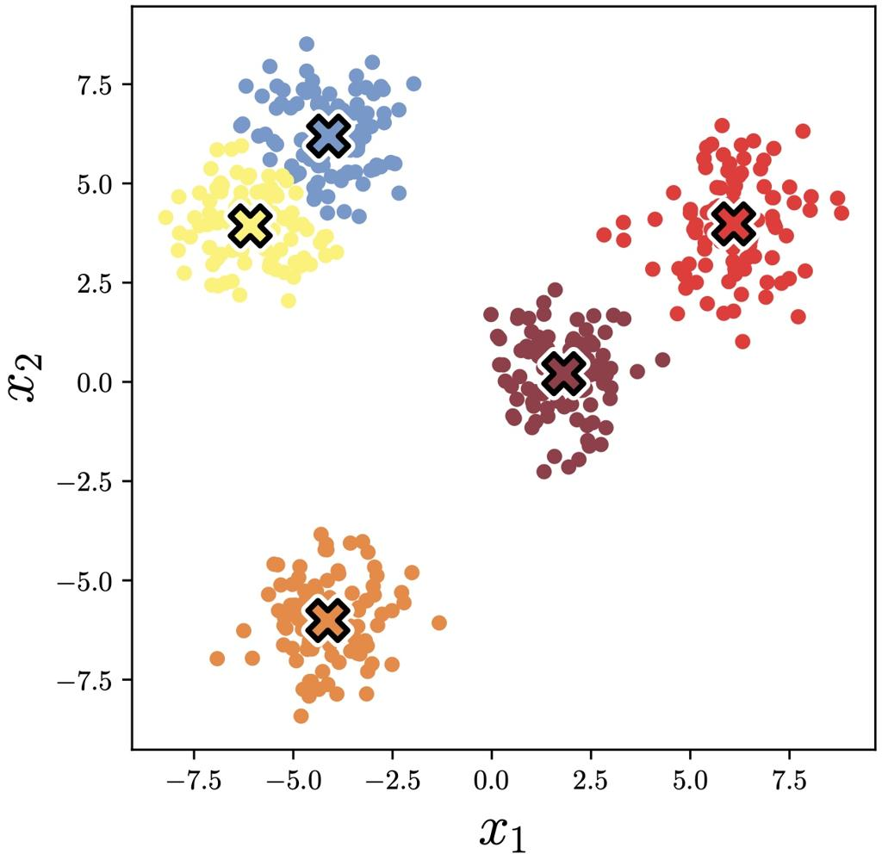
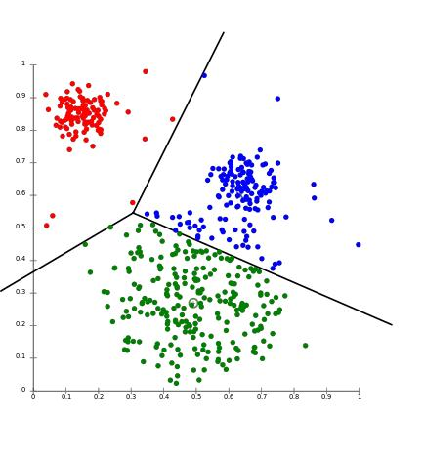
Goal
Group similar data points into K clusters.
Idea
Each cluster has a center (centroid). Points are assigned to the closest centroid.
Algorithm Steps
- Choose K cluster centers randomly.
- Assign every data point to the nearest centroid (using a distance metric like Euclidean distance).
- Recalculate the centroid as the average of all points in the cluster.
- Repeat steps 2–3 until clusters stop changing.
Intuition
It tries to minimize the distance between points and their cluster center.
Key Characteristics
- Simple and fast
- Works best when clusters are roughly spherical
- Requires choosing K beforehand

2. Expectation Maximization (EM) – Gaussian Mixture Models

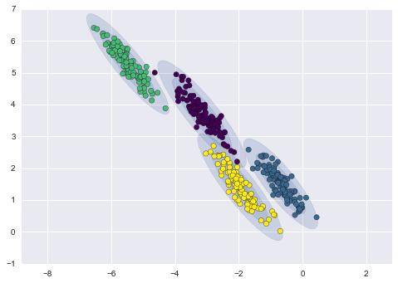
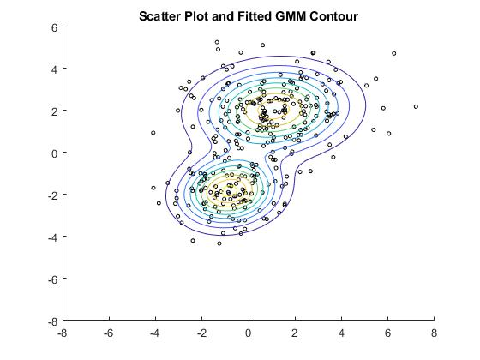
Goal
Cluster data using probability distributions instead of hard assignments.
Idea
Instead of assigning each point to one cluster, EM assigns probabilities of belonging to each cluster.
Example:
Point | Cluster A | Cluster B
x1 | 0.8 | 0.2
Algorithm Steps
E-Step (Expectation)
Estimate probability that each point belongs to each cluster.
M-Step (Maximization)
Update parameters of the Gaussian distributions (mean, covariance).
Repeat until convergence.
Intuition
Data is generated by multiple Gaussian distributions and EM tries to learn those distributions.
Key Characteristics
- Soft clustering
- Can model elliptical clusters
- More flexible than K-Means

3. Random Projection
Goal
Reduce dimensionality while preserving distances between points.
Idea
Project high-dimensional data onto a random lower-dimensional space.
Example:
1000 dimensions → 50 dimensions
Why It Works
Because of the Johnson–Lindenstrauss lemma, which states that distances are approximately preserved when projecting into a lower dimension randomly.
Process
- Generate a random projection matrix
- Multiply dataset by the matrix
- Result is a lower dimensional representation
Key Characteristics
- Extremely fast
- Computationally cheap
- Not interpretable

- Principal Component Analysis (PCA)

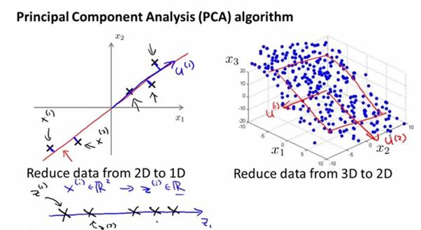

Goal
Reduce dimensions while preserving maximum variance.
Idea
Find new axes (called principal components) where the data varies the most.
Instead of original features:
x1, x2, x3, x4
PCA creates:
PC1, PC2, PC3, PC4
Where:
- PC1 = direction of maximum variance
- PC2 = second most variance (orthogonal to PC1)
Process
- Standardize data
- Compute covariance matrix
- Compute eigenvectors and eigenvalues
- Select top components
Intuition
Rotate the coordinate system to capture the most informative directions.
Key Characteristics
- Linear transformation
- Maximizes variance
- Components are orthogonal

5. Independent Component Analysis (ICA)
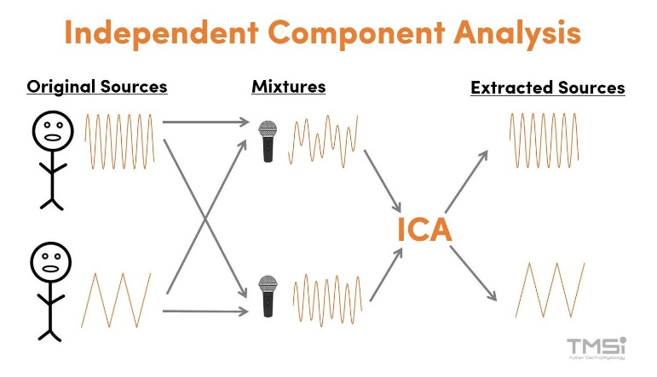

Goal
Separate independent underlying signals from observed data.
Idea
Observed data is a mixture of hidden independent sources.
Example (Cocktail Party Problem):
Two microphones record mixed voices:
Mic1 = Speaker A + Speaker B
Mic2 = Speaker A + Speaker B
ICA tries to recover:
Speaker A
Speaker B
Process
- Assume observed signals are mixtures
- Find transformation that makes components statistically independent
Key Characteristics
- Maximizes statistical independence
- Often used in signal processing
- Works well with non-Gaussian signals

Key Differences Between the Algorithms
Algorithm | Type | Purpose
K-Means | Clustering | Hard clustering based on distance
EM (GMM) | Clustering | Probabilistic clustering
Random Projection | Dimensionality Reduction | Fast random projection
PCA | Dimensionality Reduction | Preserve variance
ICA | Dimensionality Reduction | Extract independent signals

How These Fit Your Assignment
Typical workflow for the project:
Step 1
Run clustering on original dataset
K-Means
EM
Step 2
Apply dimensionality reduction
PCA
ICA
Random Projection
Step 3
Run clustering again on reduced data
K-Means + PCA
K-Means + ICA
K-Means + RP
Step 4
Compare results
Example metrics:
- cluster quality
- silhouette score
- runtime
- visualization

💡 Important insight your report should explore
How dimensionality reduction changes clustering structure.
Example hypothesis:
PCA will improve clustering performance because it removes noise and redundant features.

